**DAILY ONLINE ACTIVITIES SUMMARY**

|  |  |  |  |  |  |  |  |  |
| --- | --- | --- | --- | --- | --- | --- | --- | --- |
| **Date:** | **17 June** | | | | | **Name:** | **Shanbhag Atish Manoj** | |
| **Sem & Sec** | **6th Sem ‘B’ Sec** | | | | | **USN:** | **4AL17CS085** | |
| **Online Test Summary** | | | | | | | | |
| **Subject** | | **C programming Quiz and python workshop quiz** | | | | | | |
| **Max. Marks** | | **--** | | **Score** | | | **--** | |
| **Certification Course Summary** | | | | | | | | |
| **Course** | **Workshop exercise solving** | | | | | | | |
| **Certificate Provider** | | | **--** | | **Duration** | | | **--** |
| **Coding Challenges** | | | | | | | | |
| **Problem Statement: 1 program** | | | | | | | | |
| **Status: Executed** | | | | | | | | |
| **Uploaded the report in GitHub** | | | | | **yes** | | | |
| **If yes Repository name** | | | | | <https://github.com/atish-shanbhag/Updates> | | | |
| **Uploaded the report in slack** | | | | | **yes** | | | |

**Class and Quiz Snapshots:**

**C programming:**

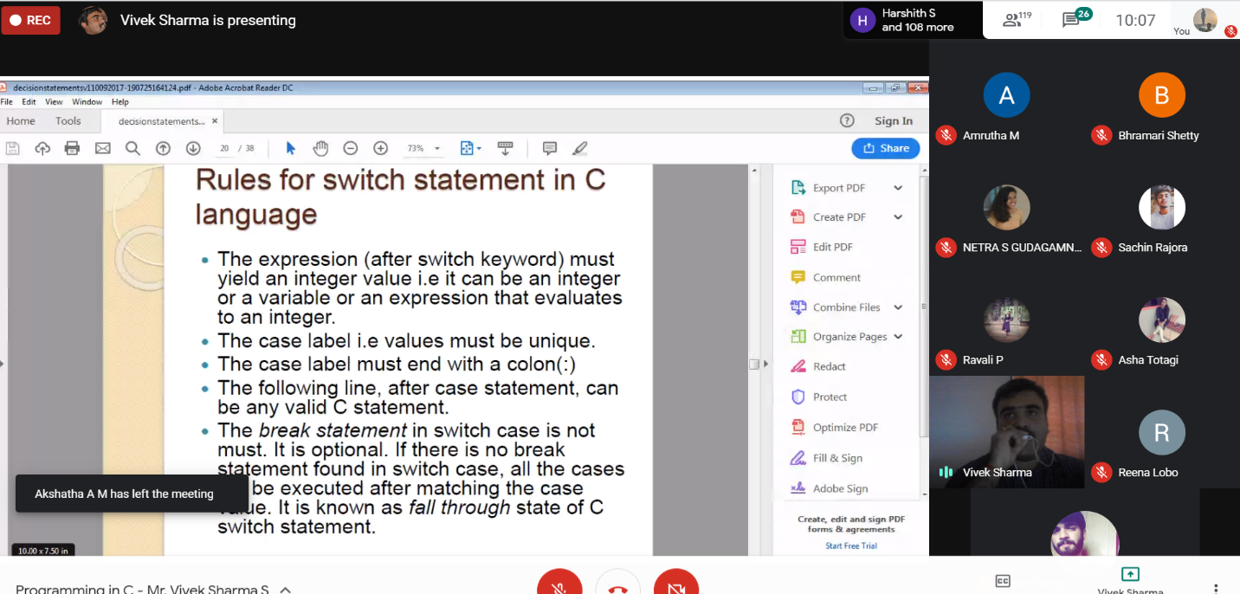

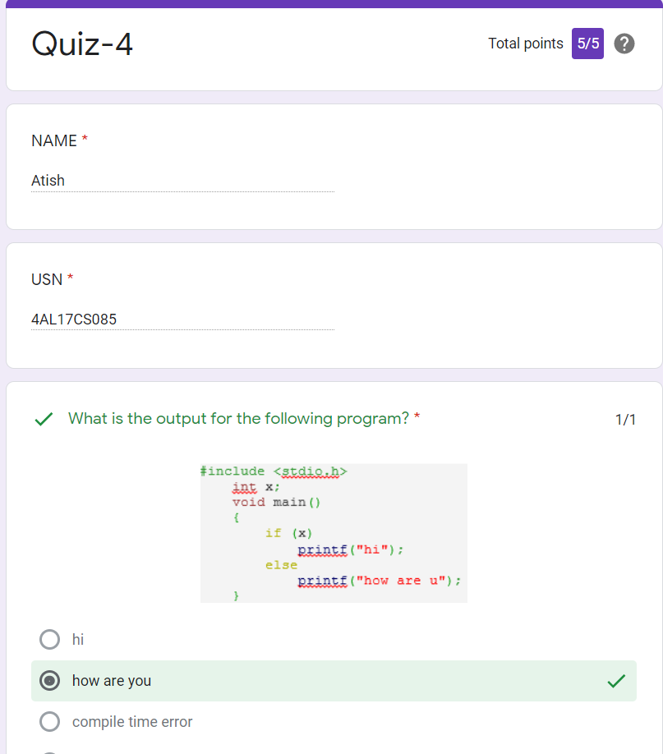

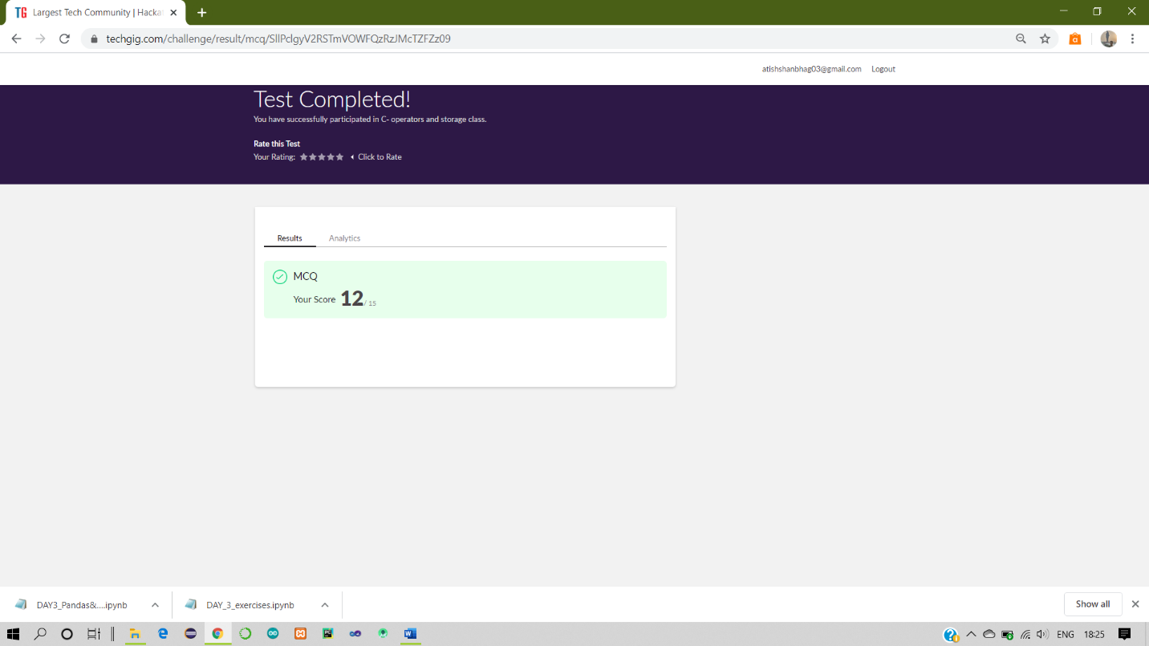

**Python workshop :**

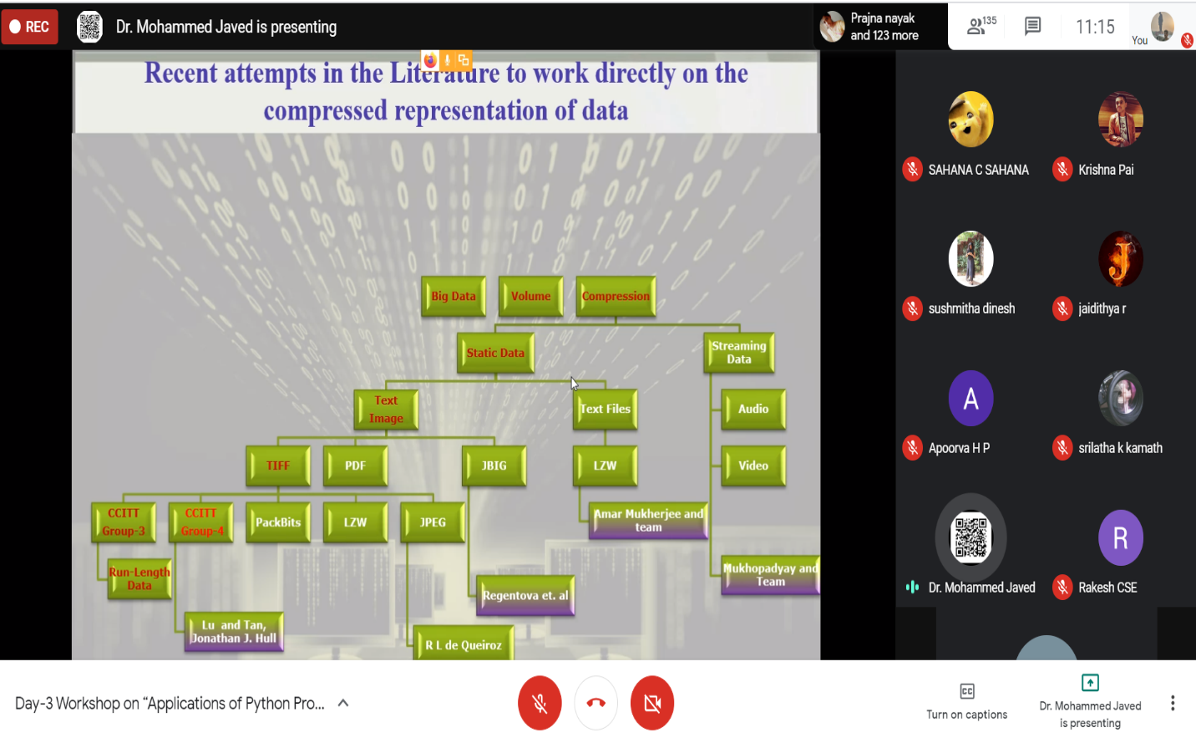

**Coding Challenges Details:**

17-June – Code:

**Program 1 Java** program to find the row, column position of a specified number in a given 2-dimensional array

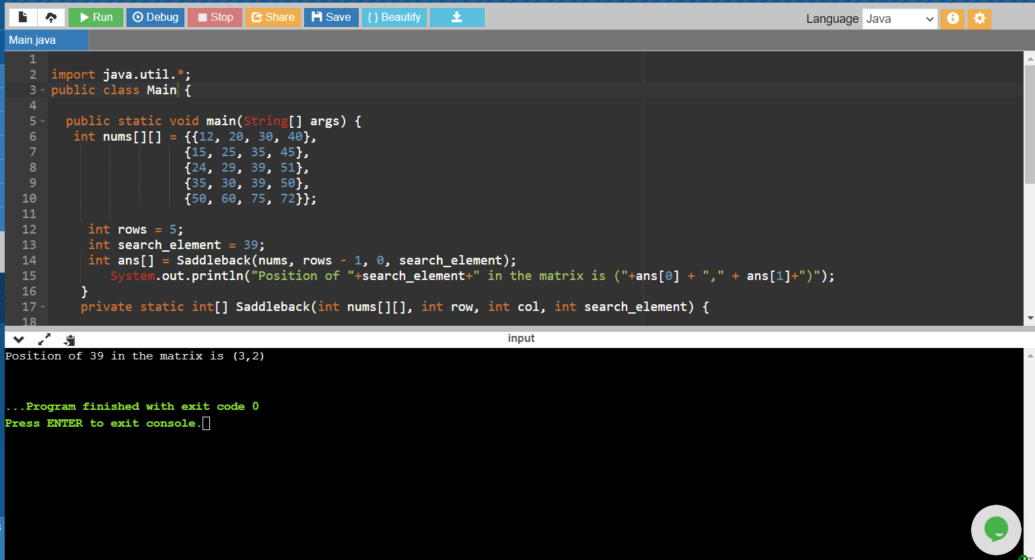

1. **For Report and daily coding challenges 🡪**[**https://github.com/atish-shanbhag/Updates**](https://github.com/atish-shanbhag/Updates)
2. **For Exercises and Worked problems of workshop 🡪**[**https://github.com/atish-shanbhag/Python_Programming_in_DA_and_ML**](https://github.com/atish-shanbhag/Python_Programming_in_DA_and_ML)